SOFTWARE REQUIREMENTS SPECIFICATION
FOR
RIDE SHARING WITH GPS
Version 1.3

Revision History
Date | Version | Description | Author | Approved
Mar-3-2015 | 1.0 | First creation | Terry, Vidal, Harold, Cody, Truman, Hanley
Apr-8-2015 | 1.1 | Add non-functional requirements, add definitions, acronyms and abbreviations | Terry
Apr-10-2015 | 1.2 | Update use case | Terry, Vidal, Harold, Cody, Truman, Hanley
Apr-14-2015 | 1.3 | Add database design | Terry
www.enclaveIT.com

Table of Contents

1. Introduction 8
1.1 Purpose 8
1.2 Scope 8
1.3 Definitions, Acronyms and Abbreviations 8
1.4 References 8
1.5 Overview 9
2. Overall Description 10
2.1 Actor 10
2.2 System function 11
2.2.1 System Use case diagram 11
2.2.2 Admin Use case diagram 14
2.2.2.1 Use case diagram –Staff Login 14
2.2.2.2 Use case diagram –Staff Logout 14
2.2.2.3 Use case diagram – Manager Staff 14
2.2.2.4 Use case diagram – Statistic 15
2.2.3 Staff Use case diagram 16
2.2.3.1 Use case diagram – Manager User 16
2.2.3.2 Use case diagram – Manager Itinerary 16
2.2.3.3 Use case diagram – Manager Feedback 17
2.2.4 User Use case diagram 17
2.2.4.1 Use case diagram – Login 17
2.2.4.2 Use case diagram – Logout 18
2.2.4.3 Use case diagram – Manage account 18
2.2.4.4 Use case diagram – Send feedback 18
2.2.4.5 Use case diagram – Statistic 19
2.2.4.6 Use case diagram – View itineraries 19
2.2.5 Customer Use case Diagram 20
2.2.5.1 Use case diagram – Join itinerary 20
2.2.5.2 Use case diagram – View schedule 20
2.2.6 Driver Use case Diagram 21
2.2.6.1 Use case diagram – Manage schedule 21
3. Specific Requirements 22
3.1 System management 22
3.1.1 Login 22
3.1.1.1 UC001-Login 22
3.1.2 Logout 22
3.1.2.1 UC002- Logout 22
3.1.3 Manage User 23
3.1.3.1 UC004-View list user 23
3.1.3.2 UC005-Delete user 24
3.1.3.3 UC006-Search user 24
3.1.3.4 UC007-View details user 25
3.1.3.5 UC008-Active user 25
3.1.3.6 UC0081-Lock user 26
3.1.4 Manage Itinerary 26
3.1.4.1 UC0082-View Itinerary 26
3.1.4.2 UC0083-Update Itinerary 27
3.1.4.3 UC0084-Delete itinerary 27
3.1.4.4 UC0085- Search itinerary 28
3.1.5 Manage Staff 28
3.1.5.1 UC009-Create staff 28
3.1.5.2 UC010-View List of Staff 29
3.1.5.3 UC011-Delete staff 29
3.1.5.4 UC012-Search staff 30
3.1.5.5 UC013-View staff details 30
3.1.5.6 UC014-Update staff 31
3.1.6 Manage Feedback 31
3.1.6.1 UC0141- View feedback 31
3.1.6.2 UC0142-Send Response 32
3.1.6.3 UC0143-Delete feedback 32
3.1.7 Analyze Statistically 32
3.1.7.1 UC0144-View History of Itineraries 33
3.1.7.2 UC0145-View Amount of Money Spent 33
3.2 User application 34
3.2.1 Login 34
3.2.1.1 UC015-Login 34
3.2.2 Logout 34
3.2.2.1 UC016- Logout 34
3.2.3 Register new account 36
3.2.3.1 UC017- User Register new account 36
3.2.4 Send Feedback 37
3.2.4.1 UC018- Send feedback 37
3.2.5 Manage account 37
3.2.5.1 UC019- View profile 37
3.2.5.2 UC020- Update profile 38
3.2.6 Manage schedule 38
3.2.6.1 UC021-View schedule 38
3.2.6.2 UC022-Delete schedule 38
3.2.7 View other user profile 39
3.2.7.1 UC023-View other user profile 39
3.2.7.2 UC024-Comment 39
3.2.7.3 UC0241-Rating 40
3.2.8 Search Itinerary 40
3.2.8.1 UC025-Search itinerary 40
3.2.9 Join an Itinerary 41
3.2.9.1 UC026- Join an Itinerary 41
3.2.10 Analyze Statistically 41
3.2.10.1 UC027-View History of Itineraries 41
3.2.10.2 UC028-View Amount of Money Spent 42
3.2.11 View New Itinerary 42
3.2.11.1 UC029-View itinerary 42
3.2.12 Post New Itineraries 43
3.2.12.1 UC030-Update itinerary 43
3.3 Database design 44
3.3.1 User table 44
3.3.2 Driver table 45
3.3.3 Vehicle table 45
3.3.4 Itinerary table 45
3.3.5 Rating table 46
3.3.6 Comment table 46
3.3.7 Feedback table 47
3.3.8 Staff table 47
4. Non-functional requirements and others 48
4.1 Performance 48
4.2 Scalability 48
4.3 Security 48
4.4 Infrastructure 48
4.5 Browser 48
4.6 Reliability 48
4.7 Purchased Components 48
4.8 Interfaces 49
4.9 Extensibility 49
4.10 Assumptions 49
5. APPENDIX 50

List of diagram

Diagram 1: System actor 8
Diagram 2: System use case for Staff 9
Diagram 3: System use case for User 10
Diagram 4: System use case for Guest 11
Diagram 5: Staff Login use case 12
Diagram 6: Staff Logout use case 12
Diagram 7: Manager Staff use case 12
Diagram 8: System Statistic use case 13
Diagram 9: Manager User use case 14
Diagram 10: Manager Itinerary use case 15
Diagram 11: Manager Feedback use case 15
Diagram 12: User Login use case 16
Diagram 13: User Logout use case 16
Diagram 14: Manage Account use case 16
Diagram 15: Send Feedback use case 17
Diagram 16: Statistic use case 17
Diagram 17: View Itineraries use case 17
Diagram 18: Join Itinerary use case 18
Diagram 19: View Schedule use case 18
Diagram 20: Manage Schedule use case 19
Diagram 21: Database structure 35

List of table

Table 1: User table 35
Table 2: Driver table 36
Table 3: Vehicle table 36
Table 4: Itinerary table 36
Table 5: Rating table 37
Table 6: Comment table 37
Table 7: Feedback table 38
Table 8: Staff table 38

Introduction
This section gives a scope description and overview of everything included in this SRS document. Also, the purpose of this document is described and a list of abbreviations and definitions is provided.

Purpose
The purpose of this document is to give a detailed description of the requirements for the “Ride Sharing with GPS” system. It will illustrate the purpose and complete declaration for the development of system. It will also explain system constraints, interface and interactions with other external application. This document is primarily intended to be proposed to a customer for its approval and a reference for developing the first version of the system for development team.

Scope
The “Ride Sharing with GPS” includes a GPS- based mobile application, a website application which help user posting, searching and join an itinerary with the other people.
By using the GPS, RESTFul web service technique, the system can help people easily find, join and tracking an itinerary.

Definitions, Acronyms and Abbreviations
Term | Definition
GPS | Global Positioning System
SRS | Software requirement specification
AWS | Amazon Web Services – A cloud computing platform provided by Amazon.com
REST | Representational State Transfer – An architectural style for networked hypermedia applications
RESTFul | Web service APIs that adhere to the REST architectural constraints
API | Application program interface - A set of routines, protocols, and tools for building software applications

References
- RS – Test plan v1.0
- RS – Java Coding Convention v1.0
- RS – C Sharp Coding Convention v1.0
- RS – PHP Coding Convention v1.0
- RS – Planner
- RS – Test Case v1.0

Overview
The remainder of this document includes three chapters. The first describes the general view of the system through use case diagram. This section does not state specific requirements. Instead, it provides a background for those requirements, which are defined in detail in the second chapter, and make them easier to understand.
The second chapter provides all software requirements to a level of detail sufficient to enable designers to design a system to satisfy those requirements and testers to test that the system satisfies those requirements.
The last chapter describe non-functional requirements and others.

Overall Description

Actor
The below diagram describes all actors of the Ride Sharing with GPS System. An actor represents Guest Role, an actor represents a User Role, Driver and Customer Account derive from User, another actor is represents for Staff Role, Admin Account derive from Staff. Each user has his own actions when accessing into the system, based on his rights. Driver Account have right to login, create new vehicle, update vehicle, delete vehicle, post new itinerary, update itinerary, delete itinerary, view and update profile, view statistic, accept an request to join an itinerary from customer and logout.
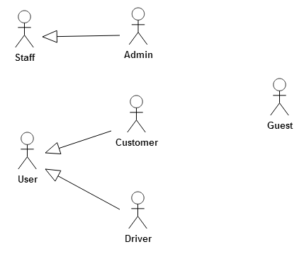
Diagram 1: System actor
Actor | Description
Guest | Have the rights to register new account, visit website to view information about the system
User | Have right to login, activate their account, reset password when forgot, send feedback about the system and logout
Customer | Have right to view and update their profile, search itineraries, join and cancel an itinerary, tracking an itinerary, view schedule of itineraries, view statistic,
Driver | Have right to create new vehicle, update vehicle, delete vehicle, post new itinerary, update itinerary, delete itinerary, view and update profile, view statistic, accept and deny an request to join an itinerary from customer and tracking an itinerary
Staff | Have right to login, manage User, manage itineraries, manage feedback from user, monitor all itinerary and logout
Admin | Have right to manage Staff, view statistic.

System function

System Use case diagram

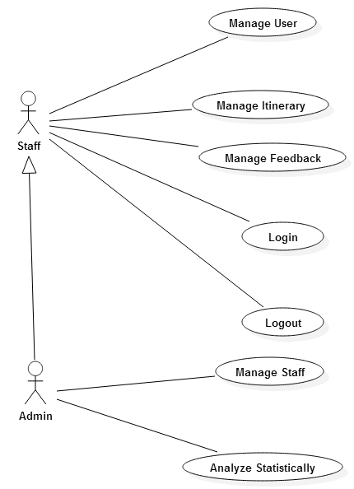

Diagram 2: System use case for Staff

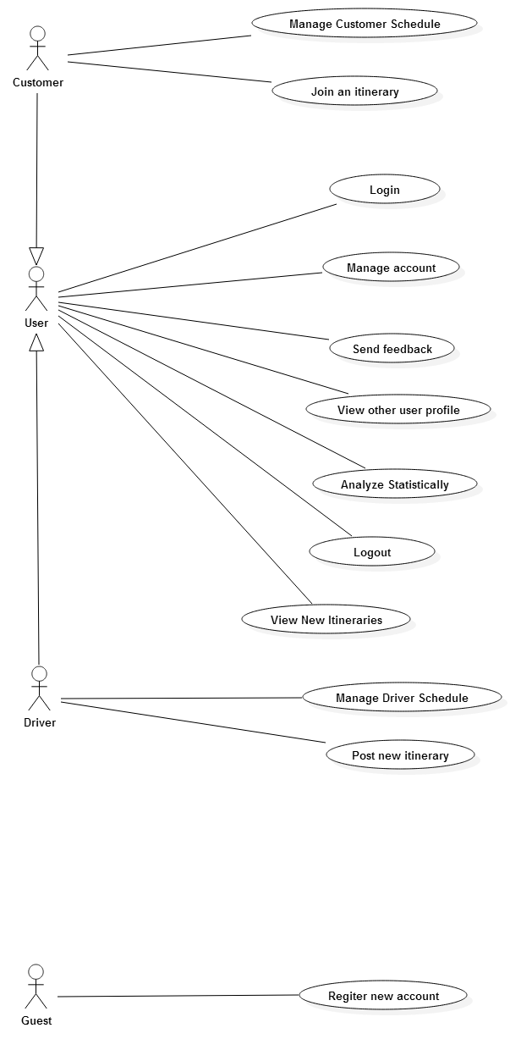

Diagram 3: System use case for User
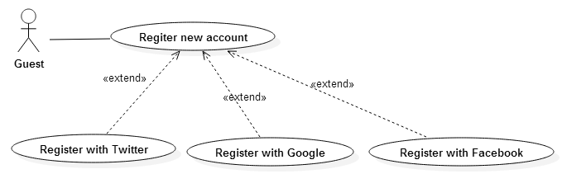

Diagram 4: System use case for Guest

Admin Use case diagram

Use case diagram –Staff Login

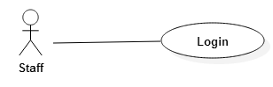
Diagram 5: Staff Login use case

Use case diagram –Staff Logout

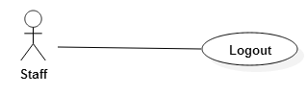
Diagram 6: Staff Logout use case

Use case diagram – Manager Staff
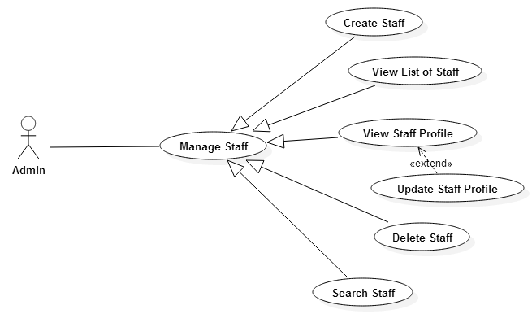
Diagram 7: Manager Staff use case

Use case diagram – Statistic

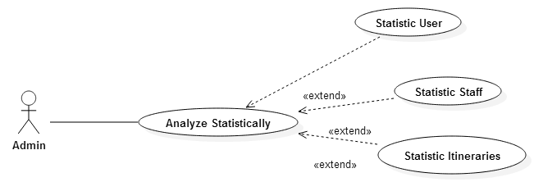
Diagram 8: System Statistic use case

Staff Use case diagram

Use case diagram – Manager User

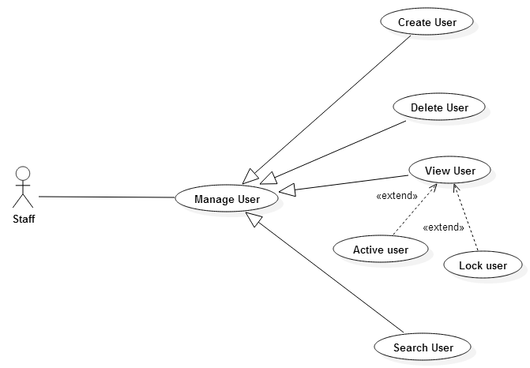
Diagram 9: Manager User use case

Use case diagram – Manager Itinerary

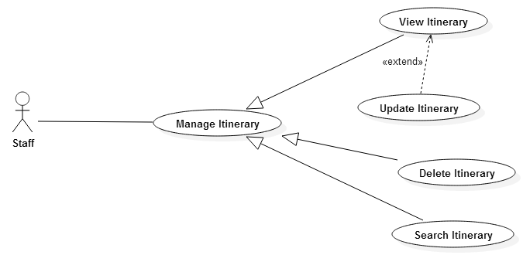
Diagram 10: Manager Itinerary use case

Use case diagram – Manager Feedback

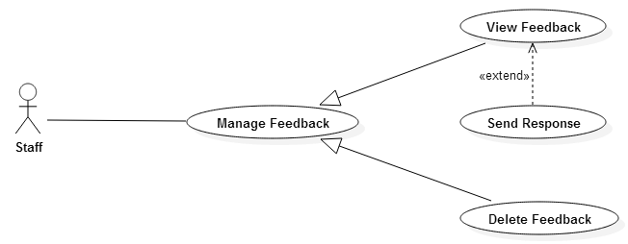
Diagram 11: Manager Feedback use case

User Use case diagram

Use case diagram – Login

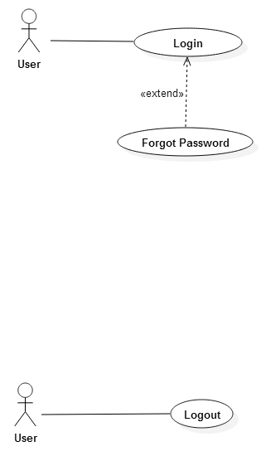
Diagram 12: User Login use case

Use case diagram – Logout

Diagram 13: User Logout use case

Use case diagram – Manage account

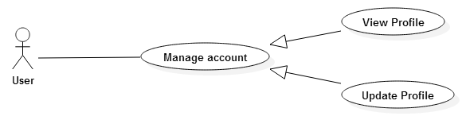
Diagram 14: Manage Account use case

Use case diagram – Send feedback

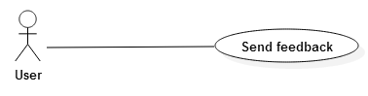
Diagram 15: Send Feedback use case

Use case diagram – Statistic

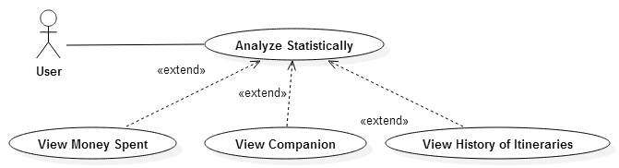
Diagram 16: Statistic use case

Use case diagram – View itineraries

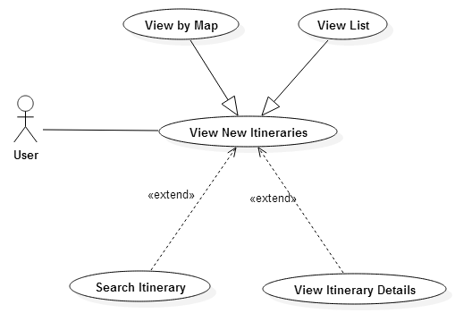
Diagram 17: View Itineraries use case

Customer Use case Diagram

Use case diagram – Join itinerary

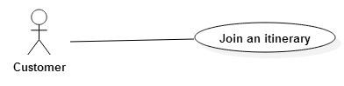
Diagram 18: Join Itinerary use case

Use case diagram – View schedule

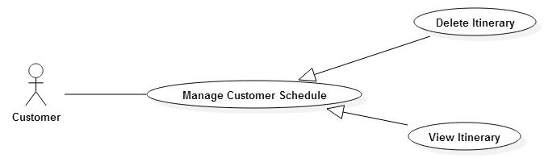
Diagram 19: View Schedule use case

Driver Use case Diagram

Use case diagram – Manage schedule

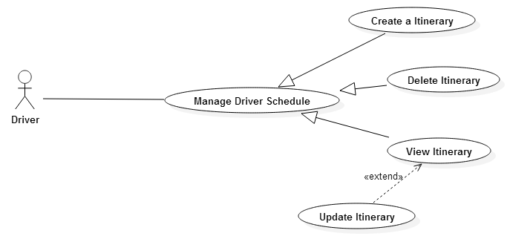
Diagram 20: Manage Schedule use case

Specific Requirements
This section contains all of the functional and quality requirements of the system. It gives a detailed description of the system and all its features.

System management

Login

UC001-Login
Priority: High

Brief Description
This use case allow staff login to system management.

Pre-Condition
The staff already have an account.

Post-Condition
The main screen is displayed, the staff’s API key was store in Session.

Flow of Events
- Basic flow
Step | Description
1 | Staff type email and password in “Email” field and “Password” field
2 | Staff click the “Login” button
3 | System’s main screen is displayed in the screen

- Alternative flow
Step | Description
3.1 | System display “Wrong email or password” message
3.2 | System display “The email does not exist” message

Screen S001 – Staff Login

Logout

UC002- Logout
Priority: High

Brief Description
This use case allow staff logout their account from system.

Pre-Condition
Staff have to login to system.

Post-Condition
The login screen display, the staff’s API key was remove from Session.

Flow of Events
- Basic flow
Step | Description
1 | Staff click the “Logout” button on the left corner or on the right menu
2 | Screen is displayed “Do you want to logout?”
3 | Staff click “Yes” button
4 | System redirect to the login screen

- Alternative flow
Step | Description
3.1 | Staff click “No” button
4.1 | System redirect to main screen

Manage User
Priority: High

UC004-View list user

Brief Description
This Use case allow staff to view list of user profile.

Pre-Condition
The staff has login to system.

Post-Condition

Flow of Events
Step | Description
1 | Staff click “Manage user” on the right menu.
2 | System display list of user profile.

UC005-Delete user

Brief Description
This Use case allow staff delete one, many or all of user profile.

Pre-Condition
The staff has accessed the “Manage user” screen.

Post-Condition
Database is updated.

Flow of Events
- Basic flow
Step | Description
1 | Staff choose the user in List User they want to delete
2 | Staff click “Delete” button
3 | System display message: “Do you want to delete?”
4 | Staff click “Yes” button
5 | User was deleted from the system

- Alternative flow
Step | Description
4.1 | Staff click “No” button
5.1 | System redirect to “Manage user” screen

UC006-Search user

Brief Description
This Use case allows staff search user by name.

Pre-Condition
The user has accessed “Manage user” screen.

Post-Condition

Flow of Events
- Basic flow
Step | Description
1 | Staff enter the key word into the search’s text field
3 | Staff click “Search” button
4 | System display all result on the screen

- Alternative flow
Step | Description
4.1 | System display “No result found”

UC007-View details user

Brief Description
This Use case allows staff review the details of any user.

Pre-Condition
The staff has accessed “Manage user” screen.

Post-Condition

Flow of Events
Step | Description
1 | Staff click on the user record want to review
2 | System display details of the user that was chosen

UC008-Active user

Brief Description
This Use case allow staff active new user when their information is correct.

Pre-Condition
The staff has accessed “Manage user” screen.

Post-Condition
Database is updated.

Flow of Events
- Basic flow
Step | Description
1 | Staff choose a user in the list of user want to active
2 | Staff click “Edit” button
3 | System display “User detail” screen
4 | Staff click “Activate user” button
5 | Staff click “Save” button
6 | System redirect to “User detail” screen

- Alternative flow
Step | Description
5.1 | Staff click “Back” button
6.1 | System redirect to “Manage user” screen

UC0081-Lock user

Brief Description
This Use case allow staff lock a user.

Pre-Condition
The staff has accessed “Manage user” screen.

Post-Condition
Database is updated.

Flow of Events
- Basic flow
Step | Description
1 | Staff choose a user in the list of user want to active
2 | Staff click “Edit” button
3 | System display “User detail” screen
4 | Staff click “Lock user” button
5 | Staff click “Save” button
6 | System redirect to “User detail” screen

- Alternative flow
Step | Description
5.1 | Staff click “Back” button
6.1 | System redirect to “Manage user” screen

Manage Itinerary
Priority: High

UC0082-View Itinerary

Brief Description
This Use-case allows staff review an itinerary.

Pre-Condition
The staff must log in to the system with the valid account then navigate to the menu and choose the “Itinerary Management” feature.

Post-Condition

Flow of Events
Step | Description
1 | Staff navigate to the “View Itinerary” or “Itinerary Details” feature on a menu
2 | System display a list of all itinerary

UC0083-Update Itinerary

Brief Description
This Use-case allows staff update an itinerary.

Pre-Condition
The staff must log in to the system with the valid account then navigate to the menu and choose the “Itinerary Management” feature.

Post-Condition
Database is updated.

Flow of Events
Step | Description
1 | Staff navigate to the “View Itinerary” or “Itinerary Details” feature on a menu to update
2 | New update on a database

UC0084-Delete itinerary

Brief Description
This Use-case allows staff delete an itinerary. Have two ways to do that, first is choose and delete itinerary when navigation to the “View Itinerary” feature. The second is delete the itinerary through the “View details Itinerary” feature.

Pre-Condition
The user has accessed Manage staff main screen.

Post-Condition
Database is updated.

Flow of Events
Step | Description
1 | Staff select the itinerary on a “List of Itinerary” or “Details of Itinerary” to delete
2 | Click on a “Delete” button
3 | System will display message: “Do you want to delete?”
4 | User click “Yes” or “No” button
5 | Updating database

UC0085- Search itinerary

Brief Description
This Use-case allows staff search itineraries by the day or the position.

Pre-Condition
The user has accessed “Itinerary Management” main screen.

Post-Condition

Flow of Events
Step | Description
1 | User choose the type of key word that they want to search for
2 | User enter the key word into the text field
3 | Click on a “Search” button
4 | System will display all result on the screen

Manage Staff
Priority: Low

UC009-Create staff

Brief Description
This Use-case allows admin create a new staff.

Pre-Condition
The admin has accessed “Manage staff” screen.

Post-Condition
A new staff record is saved into the database.

Flow of Events
- Basic flow
Step | Description
1 | Admin click “Create staff” button
2 | The screen “Create staff” is displayed
3 | Staff fill in require field
4 | Staff click “Create” button
7 | New staff being created

- Alternative flow
Step | Description
7.1 | Alert “Missing require field” display
7.3 | Alert “The Personal ID” has been exist display
7.2 | Alert “The email has been exist” display

UC010-View List of Staff

Brief Description
This Use-case allows admin to view list of staff profile.

Pre-Condition

Post-Condition

Flow of Events
Step | Description
1 | Admin click “Manage staff” button on the right menu.
2 | The screen display list of staff profile.

UC011-Delete staff

Brief Description
This Use-case allows admin delete one, many or all of staff profile. Having two ways to do that. The first way is use can choose and delete staff when admin are using View staff function. The second way is use can delete the current receiving when use View details staff function.

Pre-Condition
The user has accessed Manage staff main screen.

Post-Condition
Database is updated.

Flow of Events
Step | Description
1 | User choose the staff in List Staff or Detail Staff that they want to delete
2 | Click “Delete” button
3 | System will display message: “Do you want to delete?”
4 | User click “Yes” button
5 | Update database

UC012-Search staff

Brief Description
This Use case allows user search staff by Name or by Personal ID.

Pre-Condition
The user has accessed manage staff main screen.

Post-Condition
Display all of result about staff with key word was entered.

Flow of Events
Step | Description
1 | User choose the type of key word that they want to search for.
2 | User enter the key word into the text field
3 | User click “Search” button
4 | System will display all result on the screen

UC013-View staff details

Brief Description
This Use case allows user review the details of any staff. This function is used after user use View staff.

Pre-Condition
The user has accessed Manage staff main screen.

Post-Condition
The details of staff that is chosen will display on the screen.

Flow of Events
Step | Description
1 | User click on the staff record that they want to review
2 | System display details of the staff that was chosen

UC014-Update staff

Brief Description
This Use case allows user edit the content of staff profile. Having two ways to do it. The first way is when user use View staff function, they choose one of staff and edit it. The second way is when user use View details staff function, they can edit this staff.

Pre-Condition
The user has accessed Manage staff main screen.

Post-Condition
Database is updated.

Flow of Events
Step | Description
1 | User choose the staff in the staff list that they want to edit
2 | Click “Edit” button
3 | System will display screen allows user edit
4 | User edit information they want
5 | Click “Save” button

Manage Feedback
Priority: Low

UC0141- View feedback

Brief Description
This Use-case allows staff review all feedback from user.

Pre-Condition
The staff must log in to the system with the valid account then navigate to the menu and choose the “Feedback Management” feature.

Post-Condition

Flow of Events
Step | Description
1 | Staff navigate to the “View Feedback” feature on a menu
2 | System display a list of feedback

UC0142-Send Response

Brief Description
This Use-case allows staff send response to user through their feedback.

Pre-Condition
The staff must log in to the system with the valid account then navigate to the menu and choose the “Feedback Management” feature.

Post-Condition

Flow of Events
Step | Description
1 | Staff navigate to the “List of Feedback” feature
2 | Staff choose the feedback
3 | Type the response into the text field
4 | Click the “Send” button
5 | New response is updated into Database

UC0143-Delete feedback

Brief Description
This Use-case allows staff delete a feedback.

Pre-Condition
The staff has accessed Manage Feedback main screen.

Post-Condition
Database is updated.

Flow of Events
Step | Description
1 | Staff select the feedback on a “List of Feedback” to delete
2 | Click on a “Delete” button
3 | System will display message: “Do you want to delete?”
4 | Click on a “Yes” or “No” button
5 | Updating database

Analyze Statistically
Priority: Medium

UC0144-View History of Itineraries

Brief Description
This Use-case allows user view the list of itinerary in the past.

Pre-Condition
The user must log in to the system with their valid account and navigate to the menu and choose the Analyze Statistically feature.

Post-Condition

Flow of Events
Step | Description
1 | User click on “Analyze Statistically” feature on menu
2 | Display the Analyze Statistically screen
3 | User click on “History of Itineraries” button
4 | System will display all the list of itineraries

UC0145-View Amount of Money Spent

Brief Description
This Use-case allows user review the history of the payment.

Pre-Condition
The user must log in to the system with their valid account then navigate to the menu and choose the “History of Payment” feature.

Post-Condition

Flow of Events
Step | Description
1 | User click on “Analyze Statistically” feature on menu
2 | The screen of Analyze Statistically is displayed
3 | User click on “History of Payment” button
4 | System will display a history of payment

User application

Login

UC015-Login
Priority: High

Brief Description
This use case allow user to login into this application.

Pre-Condition
The user have to register new account and activate account via email.

Post-Condition

Flow of Events
- Basic flow
Step | Description
1 | User type email and password in “Email” field and “Password” field
2 | User click the “Login” button
3 | Application's main screen is displayed in the screen

- Alternative flow
Step | Description
3.1 | If user doesn't enter email, system will show an error message “Please enter email!”
3.2 | If user doesn't enter password, system will show an error message “Please enter password!”
3.3 | If email isn't existed or password is wrong, system will show an error message “Wrong email or password!”

Logout

UC016- Logout
Priority: High

Brief Description
This Use case allow user logout their account from application.

Pre-Condition
User have login to the system.

Post-Condition
The user’s API key was remove from Session.

Flow of Events
- Basic flow
Step | Description
1 | User click to the “Logout” button on the right menu
2 | Screen is displayed “Do you want to logout?”
3 | User click “Yes” button
4 | System redirect to the login screen

- Alternative flow
Step | Description
3.1 | User click to the “No” button
4.1 | System redirect to the main screen

Register new account

UC017- User Register new account
Priority: High

Brief Description
This user-case is for the user registration. A user must register before they are able to log on the system. Registration primarily consists of entering an email address for verification and creating a password

Precondition:
User is not a member of the system

Post Condition:
Database was updated

Flow of Events
- Basic flow

Step | Description
1 | User enters their email address and password in “Email” and “Password” field
2 | System validates that the email does not already exists. If it does not, a new user is created and a confirmation email is sent with a confirmation link that needs to be selected before the user is allowed to enter the system.
3 | User checks their email for the email that the system sent and gets the confirmation link. The user selects the confirmation link.
4 | System accepts the confirmation link and requests the user to log in using their email and password

- Alternative flow

Step | Description
2.1 | If user doesn't enter email, System will show an error message “Please enter email!”
2.2 | If user doesn't enter password, System will show an error message “Please enter password!”
2.3 | If email is existed, System will show an error message “This email is existed!”
2.4 | If password isn't from 6 to 12 characters, System will show an error message “Password has to be from 6 – 12 characters”

Send Feedback

UC018- Send feedback

Brief Description
This Use case allows user or rider to send anything about application to administrator.

Pre-Condition
User have open the function menu.

Post-Condition
Display the text field and button “Send” in order to write user’s feedback.

Flow of Events
Step | Description
1 | User click to the “Feedback” Section.
2 | Screen is displayed the Feedback text field and buttons is: “Send feedback”.
3 | User write feedback in the text field.
4 | User click “Send feedback” button to send the feedback.
5 | The screen will display: “Are you sure?”
6 | Click “Yes” button to send or “No” button to cancel.

Manage account
Priority: High

UC019- View profile

Brief Description
This use case allow user to view and manage their profile.

Pre-Condition
The user who already logged account then click on Account Management Menu.

Post-Condition
User profile will display in the screen.

Flow of Events
Step | Description
1 | Choose the User's Profile field.
2 | User's profile is displayed on the screen.

UC020- Update profile

Brief Description
This Use-case allows user update any basic information about their profile.

Pre-Condition
The user must log in to the system with the valid account then navigate to the menu and choose the “Account Management” feature.

Post-Condition
The database is updated.

Flow of Events
Step | Description
1 | User navigate to the “Account Management” feature on a menu to update
2 | Click on a “Update” button
3 | Fill the Information need to update
4 | New update on a database

Manage schedule
Priority: High

UC021-View schedule

Brief Description
This Use case allows user view schedule.

Pre-Condition
The user has login to application.

Post-Condition

Flow of Events
Step | Description
1 | User click on “Menu” button
2 | The screen of menu is displayed
3 | User click on “Schedule” button on menu
4 | The list of Schedule is displayed

UC022-Delete schedule

Brief Description
This Use case allows user delete schedule.

Pre-Condition
The user has login to application.
The user has accessed “View schedule” screen

Post-Condition
Database is updated.

Flow of Events
Step | Description
1 | User click on schedule need to delete
2 | The action button for this schedule is displayed
3 | Use click “Delete” button
4 | System will display message: “Do you want to delete?”
5 | User click “Yes” button
6 | Update database

View other user profile

UC023-View other user profile

Brief Description
This Use case allows user view other profile.

Pre-Condition
The user has login to application.
The user has accessed “Itinerary detail” screen

Post-Condition

Flow of Events
Step | Description
1 | User click on the name of other user
2 | The screen of profile of another user is displayed

UC024-Comment

Brief Description
This Use case allows user comment about another user.

Pre-Condition
The user has login to application.
The user has accessed “Itinerary detail” screen

Post-Condition
A new comment is saved into the database.

Flow of Events
Step | Description
1 | User click on the name of other user
2 | The screen of profile of another user is displayed
3 | Use click on “Comment” button
4 | User type comment content
5 | User click on “Send” button
6 | User’s comment is displayed
11 | Update database

UC0241-Rating

Brief Description
This Use case allows user rate another user.

Pre-Condition
The user has login to application.
The user has accessed “Itinerary detail” screen

Post-Condition
A new rating is saved or update into the database.

Flow of Events
Step | Description
1 | User click on the name of other user
2 | The screen of profile of another user is displayed
3 | Use click on “Rating” button
4 | Update database

Search Itinerary

UC025-Search itinerary

Brief Description
This use case allows user search itinerary by date-time or by Address or by Name of rider or by Money.

Pre-Condition
The user has accessed Customer main screen.

Post-Condition
Display all of result about itinerary with key word was entered.

Flow of Events
Step | Description
1 | User choose the type of key word that they want to search for. They are Address, Name of rider, Money or date-time.
2 | User enter the key word into the text field
3 | User click “Search” button
4 | System will display all result on the screen

Join an Itinerary

UC026- Join an Itinerary

Brief Description
This use case allows customer join an itinerary.

Pre-Condition
The user has accessed Customer main screen.

Post-Condition
A request message is sent to rider.

Flow of Events
Step | Description
1 | User click on “Send a request” button
2 | System display message: “Are you sure?”
3 | User click “Yes” button
4 | System handle the request

Analyze Statistically
Priority: High

UC027-View History of Itineraries

Brief Description
This Use case allows user view the list of itinerary in the past.

Pre-Condition
The user has open the function menu.

Post-Condition
A list of itinerary in the past of system are displayed.

Flow of Events
Step | Description
1 | User click on “Analyze Statistically” section on menu.
2 | The screen of Analyze Statistically is displayed
3 | User click on “History of Itineraries” button.
4 | System will display list of itinerary in the past.

UC028-View Amount of Money Spent

Brief Description
This Use case allows user view the amount of money has been spent.

Pre-Condition
The user has open the function menu.

Post-Condition
A total amount of money and the amount of money for each itinerary are displayed.

Flow of Events
Step | Description
1 | User click on “Analyze Statistically” section on menu.
2 | The screen of Analyze Statistically is displayed
3 | User click on “Amount of Money Spent” button.
4 | System will display A total amount of money and the amount of money for each itinerary.

View New Itinerary
Priority: High

UC029-View itinerary

Brief Description
This Use-case allows user view list of itinerary.

Pre-Condition
The user has accessed manage itinerary main screen.

Post-Condition

Flow of Events
Step | Description
1 | User click on “Menu” button
2 | The screen of menu is displayed
3 | User click on “Manage Itinerary” button on menu
4 | The list of Schedule is displayed by list
5 | User can choose kind of itineraries

Post New Itineraries
Priority: High

UC030-Update itinerary

Brief Description
This Use-case allows user edit itinerary.

Pre-Condition
The user has accessed “View detail schedule” screen.

Post-Condition
Database is updated.

Flow of Events
Step | Description
1 | User click on “Edit Itinerary” button.
2 | The dialog for edit information of itinerary is displayed.
3 | Use change information they want
4 | User click “Confirm” button
5 | Update database

Database design

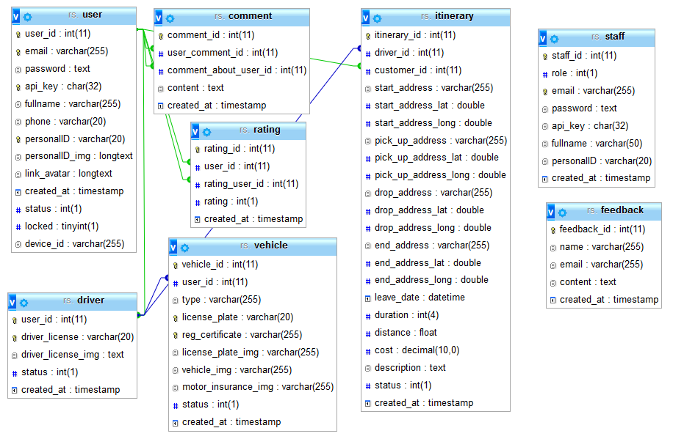
Diagram 21: Database structure

User table
Table 1: User table
No | Field name | Data type | Key | Note
1 | user_id | int(11) | P | Auto increment
2 | email | varchar(255)
3 | password | text
4 | api_key | char(32)
5 | fullname | varchar(255)
6 | phone | varchar(20)
7 | personalID | varchar(20)
8 | personalID_img | varchar(255)
9 | link_avatar | varchar(255)
10 | create_at | timestamp
11 | status | int(1)

Driver table
Table 2: Driver table
No | Field name | Data type | Key | Note
1 | user_id | int(11) | P | Auto increment
2 | driver_license | varchar(20)
3 | driver_license_img | varchar(255)
4 | created_at | timestamp

Vehicle table
Table 3: Vehicle table
No | Field name | Data type | Key | Note
1 | vehicle_id | int(11) | P | Auto increment
2 | user_id | int(11) | F
3 | type | varchar(255)
4 | license_plate | varchar(20)
5 | reg_certificate | varchar(255)
6 | license_plate_img | varchar(255)
7 | vehicle_img | varchar(255)
8 | motor_insurance_img | varchar(255)
9 | created_at | timestamp

Itinerary table
Table 4: Itinerary table
No | Field name | Data type | Key | Note
1 | itinerary_id | int(11) | P | Auto increment
2 | driver_id | int(11) | F
3 | customer_id | int(11) | F
4 | start_address | varchar(255)
5 | start_address_lat | double
6 | start_address_long | double
7 | pick_up_address | varchar(255)
8 | pick_up_address_lat | double
9 | pick_up_address_long | double
10 | drop_address | varchar(255)
11 | drop_address_lat | double
12 | drop_address_long | double
13 | end_address | varchar(255)
14 | end_address_lat | double
15 | end_address_lat | double
16 | leave_date | datetime
17 | duration | int(3)
18 | cost | float
19 | description | text
20 | status | int(1)
21 | created_at | timestamp

Rating table
Table 5: Rating table
No | Field name | Data type | Key | Note
1 | rating_id | int(11) | P | Auto increment
2 | user_id | int(11) | F
3 | rating_user_id | int(11) | F
4 | rating | int(1)
5 | created_at | timestamp

Comment table
Table 6: Comment table
No | Field name | Data type | Key | Note
1 | comment_id | int(11) | P | Auto increment
2 | user_comment_id | int(11) | F
3 | comment_about_user_id | int(11) | F
4 | content | text
5 | created_at | timestamp

Feedback table
Table 7: Feedback table
No | Field name | Data type | Key | Note
1 | feedback_id | int(11) | P | Auto increment
2 | user_id | int(11) | F
3 | title | varchar(255)
4 | content | text
5 | created_at | timestamp

Staff table
Table 8: Staff table
No | Field name | Data type | Key | Note
1 | staff_id | int(11) | P | Auto increment
2 | role | int(1)
3 | email | varchar(255)
4 | password | text
5 | api_key | char(32)
6 | fullname | varchar(50)
7 | personalID | varchar(20)
8 | created_at | timestamp

Non-functional requirements and others

Performance
No. | Requirement
1. | Allow at least 1000 users to access into the system at the same time
2. | Speed data loading less than 5 second

Scalability
No. | Requirement
1.
2.

Security
No. | Requirement
1. | Web Server => Window Server 2012 R2 64Bit, running Apache 2.2
2. | Database MySQL version 5.6.21

Infrastructure
No. | Requirement
1. | Webserver run on Amazon Web Service Elastic Compute Cloud (EC2)
2. | Server configuration: 1 vCPUs, 2.5 GHz, Intel Xeon Family, 1 GB memory, 30GB SSD storage

Browser
No. | Requirement
1. | Support HTML5, CSS3

Reliability
No. | Requirement
1.

Purchased Components
No. | Requirement
1.

Interfaces
No. | Requirement
1. | Responsive

Extensibility
No. | Requirement
1.

Assumptions
No. | Requirement
1.

APPENDIX

